Uber data analysis

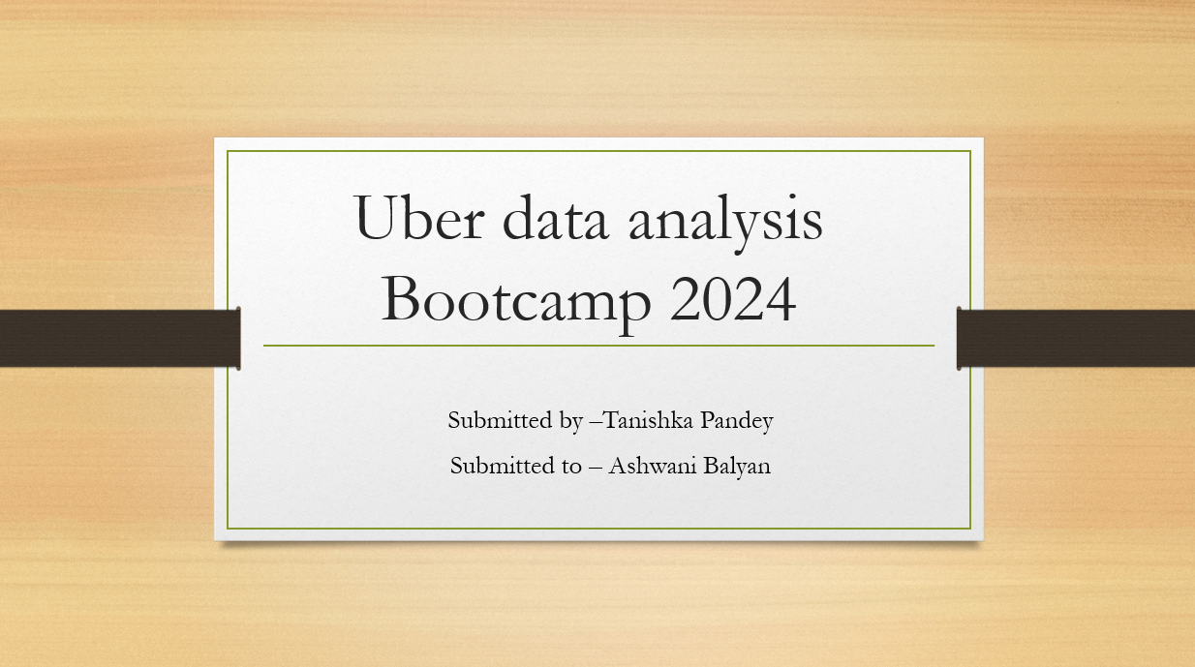

**Data**

The data contains the details for the Uber rides across various boroughs (subdivisions) of New York City at an hourly level and attributes associated with weather conditions at that time.

* **pickup_dt**: Date and time of the pick-up.
* **borough**: NYC's borough.
* **pickups**: Number of pickups for the period (hourly).
* **spd**: Wind speed in miles/hour.
* **vsb**: Visibility in miles to the nearest tenth.
* **temp**: Temperature in Fahrenheit.
* **dewp**: Dew point in Fahrenheit.
* **slp**: Sea level pressure.
* **pcp01**: 1-hour liquid precipitation.
* **pcp06**: 6-hour liquid precipitation.
* **pcp24**: 24-hour liquid precipitation.
* **sd**: Snow depth in inches.
* **hday**: Being a holiday (Y) or not (N).

This is the description of the data set and their